SALES AGREEMENT | Reference # | X_OrderNumber
SALES AGREEMENT | Date | X_Date

Seller / Shipper details:  Name: Emirundi Trade Co. Ltd  Address: PO Box 164491 Spring Road, Bugolobi, Kampala, Uganda  Email: emirunditrade@gmail.com | Buyer/Notify Party details:  Name: Fluna Trading FZCO  Address: IFZA Business Park, DDP, 001 - 36849  Dubai, United Arab Emirates  Email: sourcing@fluna.co | Consignee details:  Name: [To Be Provided]

Products | X_Product
Quality | X_Quality
Quantity | X_Quantity
Price | X_Price
Incoterms | FOT Kampala
Port of Shipment | Mombasa, Kenya
Payment Terms | 100% Cash against documents. Net shipped weights 0.5% franchise
Shipment | X_ShipmentDate
Shipping Document(s) | Standard shipping documents - Standard Forwarder's Certificate of Receipt, Commercial Invoice, Packing List / Tally Sheet, Weight Note, Certificate of Origin, Health Certificate, Phytosanitary Certificate, Quality UCDA Certificate, Fumigation Certificate
Arbitration / Applicable Conditions | European Standard Contract for Coffee (ESCC)
This Agreement has been entered into on the date stated at the beginning of this Agreement.
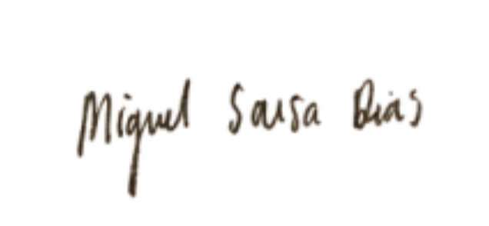  Signed by of the within-named Buyer    _____________________________  Authorized Signatory  Name: Miguel Sousa Dias  Date: X_Date |  | Signed by the within-named Seller  _____________________________  Authorized Signatory  Name: OLUMIDE BOLUMOLE  Date: X_Date

X_Incremented

TO UGANDA COFFEE DEVELOPMENT AUTHORITY
P.O BOX 7267
KAMPALA
UGANDA

Dear Sir/ Madam,

REQUEST TO REGISTER COFFEE SALE

We wish to Register sale of coffee to FLUNA TRADING - FZCO with below details:

UCDA CONTRACT | SALES REF | GRADE | QUANTITY  (BAGS) | SHIPMENT  PERIOD | PRICE  (US CENTS/LB)

Best Regards


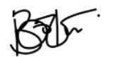

Export and Logistics
Emirundi Trade Co. Ltd

